Digital tube debugging

Learning objectives
By learning to use STM32F103RCT6 and the Nixie tube module, the digital tube can display the number you need.

Prepare before class
Connect the STM32 chip to the Nixie tube module for wiring diagrams:
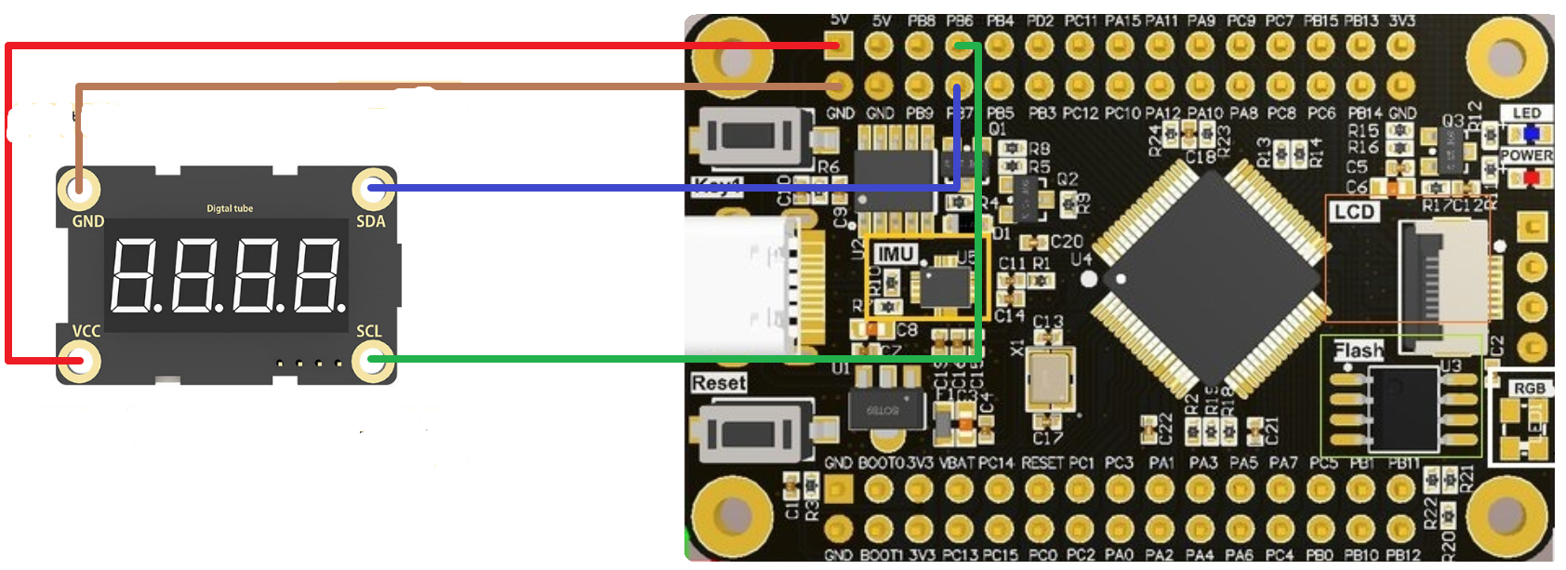

Project files
1. Programmatic
keil programming: first of all, we will use st-link as a downloader, we need to press the four connectors of st-link to connect the corresponding pin above STM32F103RCT6, then open keil, click the magic wand to select debug and select the corresponding downloader such as st-link, and then click settings to appear This interface can be downloaded normally.
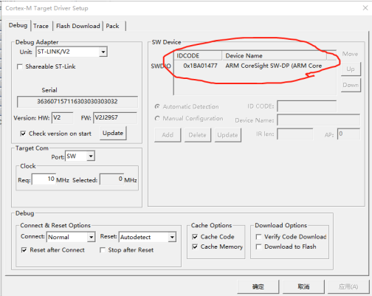
- initialize
IIC initialize：
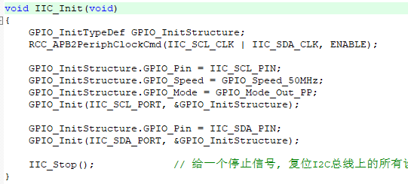
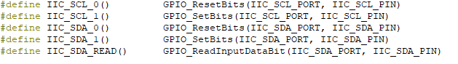
It mainly initializes the IIC interface of the Nixie tube module. There is also a display function
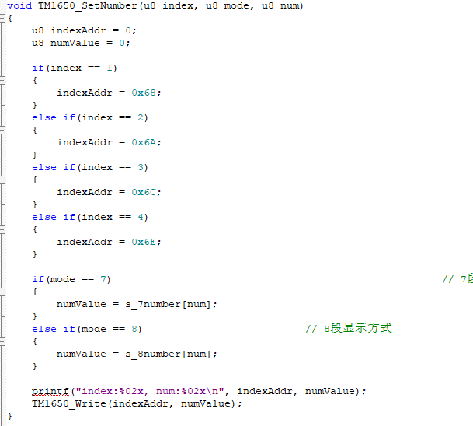
5. Main function
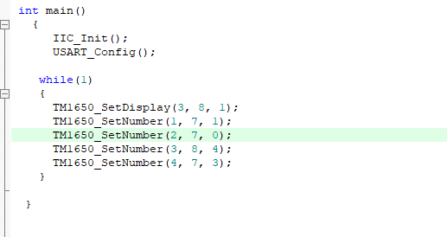

Experimental phenomenon
After the program runs successfully, when we connect the cable, we can see that 104.3 is displayed on the digital tube.
